Advanced Fire Detection Using Infrared Sensors and Neural Networks
S.Ramesh Babu,
B .Ramesh

AssistantProfessor,Dept of CSE ,Newton’s Engineering College,Palandu.
Assistant Professor, Dept of AL&ML, St. Martin’s Engineering College, Secunderabad

Abstract— Abstract— Video-based fire detection has emerged as a crucial research area for minimizing personal and property damage caused by fires. Early fire detection plays a vital role in disaster prevention, requiring high accuracy, low false alarm rates, and fast response times. This study integrates infrared sensing technology with convolutional neural networks (CNNs) to enhance fire detection accuracy and reduce false alarms. By leveraging data augmentation techniques and deploying the proposed model on embedded systems, the solution achieves real-time fire detection with improved performance compared to conventional algorithms. The results demonstrate the effectiveness of the approach in ensuring timely and reliable fire detection.
Keywords— Fire Detection, Infrared Imaging, Convolutional Neural Networks, Real-Time Systems, Data Augmentation
Introduction
Introduction
Fire is a common hazard that poses significant threats to life and property. Fires often result in substantial economic losses and personal safety risks. Early detection is crucial for preventing disasters and minimizing losses, as it allows for timely intervention and extinguishment. Conventional fire alarm systems, such as temperature-sensitive, smoke-sensitive, and photosensitive detectors, play a vital role in fire detection. However, these systems have limitations.
Temperature-sensitive detectors rely on temperature changes in the surrounding area, but their sensitivity decreases when the fire source is distant, resulting in slower response times. Smoke detectors depend on the concentration of smoke particles, which may not be sufficient for early fire detection, especially in large or well-ventilated spaces. Photosensitive detectors utilize infrared or ultraviolet bands to identify fire but are prone to interference from non-fire light sources.
With advancements in computer vision and artificial intelligence, video-based fire detection has emerged as a more effective approach. Fires exhibit unique spectral, texture, and dynamic characteristics that can be captured using cameras for real-time monitoring and processing. This method addresses the limitations of traditional detectors by enabling rapid detection, offering flexibility in deployment, and providing detailed scene information before and during the fire
Image-based fire detection offers three key advantages:
- Fast Response Time: Early detection increases the likelihood of extinguishing the fire promptly, making response time a critical parameter for fire detection systems.
- Deployment Flexibility: Unlike traditional detectors, image-based systems are less affected by the slow diffusion of heat or smoke in large or open spaces.
- Scene Awareness: Capturing visual information helps identify combustion type, fire location, and other critical details, aiding rescue and post-disaster analysis.
Recent developments in deep learning have enabled significant improvements in fire detection. Unlike traditional methods that rely on manually extracted features, deep learning automates feature extraction, resulting in faster and more accurate detection models.
This paper proposes a lightweight fire detection system that leverages infrared filters and convolutional neural networks (CNNs) to enhance performance and reliability. The key contributions of this work are as follows:
- Infrared Filters for Fire Differentiation: An infrared filter tuned to a 940 nm wavelength band effectively distinguishes fire from non-fire objects. This wavelength selectively filters sunlight while retaining the spectral characteristics of combustion, thereby improving detection efficiency.
- Lightweight Convolutional Neural Network: A small CNN, FireNet [1], is employed for fire detection. Its compact design and low parameter count make it ideal for deployment on embedded devices. Data augmentation techniques are used to enhance network performance further.
- Real-Time Deployment: The proposed model is integrated into a real-world system. Using the Hi3516CV500 chip, the device is equipped with a camera and an infrared filter, capable of detecting fire within 3 seconds. Detection results are transmitted to a computer for storage and analysis, enabling comprehensive scene monitoring.
RelatedWork

A. Traditional Fire Detection Methods
Traditional fire detection methods often rely on features such as color, motion, edges, and texture. Chen [2] proposed using RGB color and fire motion characteristics for fire detection. Qiu [3] introduced an edge-segmentation-based approach, which performs well in simple environments but struggles in complex backgrounds. Foggia [4] incorporated multiple features like color, shape, motion, and texture, achieving a detection accuracy of 93%. However, the complexity of this feature-rich system leads to slower processing times. Duan [5] improved fire detection by optimizing a Support Vector Machine (SVM) with a particle swarm algorithm, but the selected features lacked strong generalization ability, limiting the model's performance.

B. Deep Learning-Based Fire Detection Methods
Deep learning has revolutionized fire detection by automating feature extraction using convolutional neural networks (CNNs). CNNs are highly effective for image classification tasks but often require large datasets, complex architectures, and significant computational resources. For example, Muhammad used general-purpose CNNs like AlexNet [6], SqueezeNet [7], and GoogleNet [8], which are accurate but unsuitable for resource-constrained devices due to their size and high computational requirements. Yan [9] employed the Faster-RCNN model, achieving high accuracy and fast detection in complex conditions, though the model's generalization ability was limited, and its deployment on small devices was challenging. Jadon [1] developed FireNet, a compact neural network specifically for fire detection, achieving 96% accuracy and deploying it on a Raspberry Pi. However, the model showed increased loss during training, likely due to insufficient data preprocessing or limited dataset generalization.

C. Infrared-Based Fire Detection Methods
Infrared fire detection relies on the unique spectral characteristics of combustion. Different wavelength bands can be used to identify fires. Kranz [10] employed the 4400 nm and 5000 nm bands with a cross-correlation algorithm, while Huseynov [11] collected data across four bands and utilized an artificial neural network (ANN) for detection. Cai [12] focused on the 4300 nm band, using a BP neural network to achieve 92.5% accuracy, although the dataset size was insufficient. Tan [13] explored the 3800 nm, 4300 nm, and 5000 nm bands, using a LASSO regression algorithm to enhance robustness against interference. However, systems employing these bands often involve complex setups, such as binocular cameras and multiple modules, leading to detection delays and higher system complexity. Additionally, these wavelength bands cannot effectively mitigate interference from solar radiation, limiting model accuracy.
In this study, we adopt the 940 nm wavelength band for fire detection. This band minimizes interference from sunlight and can be seamlessly integrated with digital image processing techniques. Combining this approach with convolutional neural networks enables efficient fire detection while overcoming the challenges of manual feature selection and improving overall model performance.
Methodology

Methodology
This study utilizes infrared detection, data augmentation, and a convolutional neural network (CNN) to develop a fire detection algorithm, which is then deployed on a hardware device for real-time application.

A. Infrared Filters for Image Processing
Traditional fire detection methods often rely on features extracted from color spaces such as RGB, YUV, or similar. While these methods classify fire based on color, they are highly sensitive to background imaging conditions and are easily affected by environmental interference. Alternative approaches, such as extracting motion or texture features, also face limitations because fire is challenging to isolate from complex backgrounds. To enhance the distinction between fire and its background, this study employs infrared spectral characteristics, offering a robust improvement over conventional methods.
Fire is a result of the combustion of materials, producing a mixture of gases and solids that emit light, smoke, and heat. Its spectrum consists of visible light, infrared light, and ultraviolet light. By contrast, background interference often results from sunlight or other light reflections captured by the lens. Sunlight is a significant interference source in fire detection. If a distinct spectral difference between fire and sunlight can be identified, fire detection accuracy can be significantly improved.
The emission spectrum of burning materials such as ethanol, wood, candles, and methane primarily lies in the 500–6000 nm range. For instance:
- Ethanol, wood, and methane exhibit peaks around 4000–5000 nm.
- Candle flames have peaks near 1000 nm and 4000 nm.
Sunlight, on the other hand, has a consistent spectral distribution, though its energy intensity varies across different wavelength bands. Identifying specific wavelengths where sunlight's impact is minimized can reduce its interference in fire detection. For example, sunlight is absorbed by atmospheric components such as oxygen, carbon dioxide, and water vapor, which attenuates its radiation intensity at certain wavelengths, particularly around the 1400 nm or 1900 nm infrared bands.
By selecting an appropriate wavelength band for fire detection, such as those minimally affected by sunlight, this study reduces the challenges posed by environmental interference, thereby enhancing the reliability of fire detection algorithms.

By selecting an appropriate wavelength band for fire detection, such as those minimally affected by sunlight, this study reduces the challenges posed by environmental interference, thereby enhancing the reliability of fire detection algorithms.
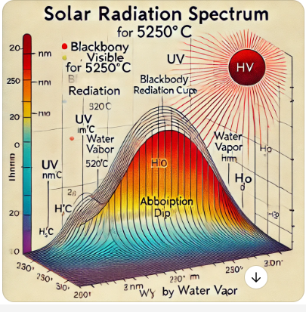
Fig.1.SolarRadiation Spectrum.

The Fig. 2 shows that the CMOS image sensor has a photosensitiverangeabove400nmandbelow1000nm,andthe imagingeffectoftheimagesensorinthebandoutsidetherange islimited.Therefore,itisnecessarytoselectawavelengthband inwhichtheradiationintensityofsunlightisatalowerlevelin the photosensitive range. Through comparison of pictures and theoretical analysis, it is found that sunlight at 940nm wavelength is absorbed by water vapor in the atmosphere, and its radiation intensity attenuates to a lower level, which is the lowestlevelbelow1100nmwhiletheburningmatterhasapart ofenergyintheinfraredband940nm,socanselectthisbandto filter the sunlight. After filtering the light, the image on the camera can distinguish the fire from the background and other interference objects.
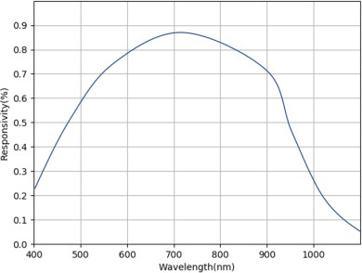
Fig.2.CMOSimagesensor'sphotosensitiverange.

InFig.3itcanbefoundthatthefireandthebackgroundare greatly separated, and their brightness is extremely different. The edge detection can be used to quickly lock the target and extractthetargetareafromthebackgroundpicture.Theroleof thefilterreducesthedifficultyofbackgroundextractionandcan findobjectsthataresuspectedoffire,avoidingerrorscausedby extracting targets based on color space. In addition to the fire, there is still a part of the background and the metal reflective area,andtheincandescentlampcanhaveobviousimaging,
whichwillinterferewiththefiredetection.Suchobjectsthatdo not have obvious regularities can be classified using convolutional neural network.
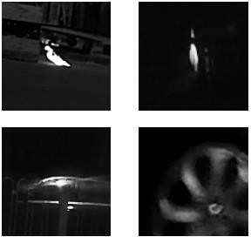
Fig.3.Fewpicturesfromourcamerawithinfraredfilter.

A. Infrared Filtering for Image Processing
Traditional fire detection techniques commonly rely on color space analysis, such as RGB and YUV, to classify fire based on its appearance. However, these methods are highly influenced by background conditions and prone to interference. Other approaches, like extracting motion or texture features, often face challenges due to the complexity of isolating fire from the background. To address these limitations, this study employs infrared spectral characteristics, providing a more effective way to distinguish fire from its surroundings.
Fire, a product of combustion, emits a mixture of gases and solids accompanied by light, smoke, and heat. Its spectrum covers visible, infrared, and ultraviolet light. Conversely, background interference, primarily from sunlight and light reflections, complicates detection. Identifying a spectral range where fire and sunlight differ significantly can simplify fire detection.
Burning materials like ethanol, wood, candles, and methane emit energy within the 500–6000 nm range:
- Ethanol, wood, and methane exhibit peaks around 4000–5000 nm.
- Candle flames show peaks near 1000 nm and 4000 nm.
Meanwhile, sunlight maintains a consistent spectral distribution with variable intensities across wavelengths. Certain wavelengths, particularly in the infrared range (e.g., 1400 nm and 1900 nm), experience attenuation due to absorption by atmospheric oxygen, water vapor, and carbon dioxide. A specific wavelength like 940 nm, where sunlight intensity is minimized due to water vapor absorption, is optimal for distinguishing fire.
Using a 940 nm wavelength filter enables the camera to reduce sunlight interference while capturing fire emissions. This approach enhances image contrast, making it easier to isolate fire from the background and other interfering objects, such as reflective metals and incandescent lamps.

B. Data Augmentation for Dataset Preparation
Infrared video datasets are typically limited in size, posing challenges for training large CNNs. Addressing this, the study applies data augmentation techniques, such as geometric transformations and image fusion, to simulate diverse scenarios. This increases the dataset size, enhances robustness, accelerates training convergence, and reduces overfitting. Data augmentation has been shown to improve prediction accuracy and stability significantly, making it indispensable for the development of high-performing models.

C. Convolutional Neural Network for Image Classification
Infrared images capture objects with high brightness while effectively minimizing background interference. By using image segmentation, objects can be separated from the background for further classification. A CNN is then employed to classify the segmented objects as fire or non-fire. Compared to traditional image processing methods, CNNs autonomously extract image features, eliminating the need for manual feature selection and improving classification accuracy.
This study employs FireNet, a lightweight CNN specifically designed for fire detection. FireNet comprises 14 layers, including 3 convolutional layers, with the first two using ReLU activation functions and the last employing Softmax. The network's small size (646,818 parameters and a 7 MB training model) ensures efficient deployment on devices, maintaining fast processing speeds. Infrared-filtered images, being single-channel grayscale images, emphasize contour features for fire detection while excluding background texture details.

D. Deployment on Hardware Devices
The fire detection algorithm is deployed on a Hi3516CV500 chip, designed for camera-based applications. This dual-core Cortex-A7@900MHz chip is well-suited for neural network operations. The camera, equipped with an infrared filter, captures images processed by the CNN to classify fire in real time. The system outputs classification results via a computer interface, allowing real-time monitoring and scene analysis.
.

Results

A. Dataset Creation
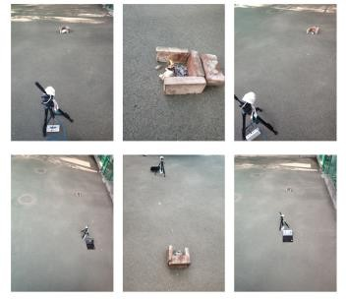
The dataset includes images from infrared-filtered videos, capturing burning materials (e.g., candles, paper, gasoline) under various conditions (indoor, outdoor, sunlight, and incandescent light). These images are classified into positive (fire) and negative (non-fire) samples. Data augmentation further expands the dataset, resulting in 25,316 images split into training (70%), testing (30%), and validation sets.

B. Neural Network Training
FireNet was trained for 50 iterations, dynamically incorporating data augmentation to improve robustness and convergence. Training results demonstrated higher accuracy and reduced overfitting, with a final accuracy rate of 97%.

C. Comparison with Similar Methods
Table I compares this study’s method with existing fire detection algorithms. While some methods use deep learning or image processing, this study’s approach combines lightweight CNN architecture and infrared filtering for enhanced accuracy and deployment feasibility.

.

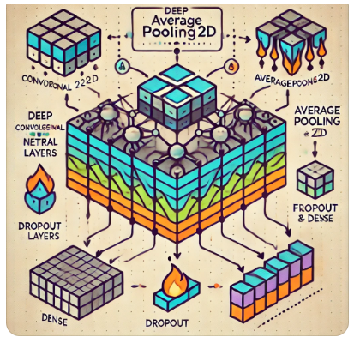
Fig.5.Overview of the camera with alogrithm deployed and its

Fig.6. Training and validation curves for model accuracy after dataaugmentation.

TABLEI. ComparisonwithDifferentFireDetectionMethods.

Metrices | ACC | FA | F-Measure
Ourmethod | 0.27 | 0.09 | 0.95
Muhammad[7] | 0.95 | 0.11 | 0.87
Muhammad[6] | 0.82 | 0.02 | 0.21
ArpitJadon[1] | 0.45 | 0.06 | 0.97
R.DiLascio [15] | 0.93 | 0.06 | /
Foggia[4] | 0.42 | 0.11 | /
Y.H. Habiboğlu[16] | 0.90 | 0.05 | /
Cai[12] | 0.92 | 0.06 | /

- Conclusion

Conclusion
This study demonstrates the integration of infrared filters and deep learning for real-time fire detection. Infrared filtering enhances anti-interference and background extraction capabilities, while FireNet ensures high-speed, lightweight algorithm performance. The proposed system achieves higher accuracy and reduced false alarms, offering practical value for fire detection in indoor and outdoor scenarios. Future work will involve expanding the dataset to include diverse environments and optimizing the network for faster deployment and real-time detection
References
- Jadon,A.,Omama, M., Varshney,A., Ansari, M.S.,Sharma,R. “Firenet:A specialized lightweight fire & smoke detection model for real-time iotapplications,”. arXiv 2019, arXiv:1905.11922.
- Thou-HoChen,Ping-HsuehWuandYung-ChuenChiou,“Anearlyfire-detection method based on image processing,” International Conferenceon Image Processing,2004. ICIP '04, vol. 3, pp. 1707-1710 ,2004.
- T.Qiu,Y.Yan,andG.Lu,“Anautoadaptiveedge-detectionalgorithmforflameandfireimageprocessing,”IEEETransactionsonInstrumen-tationand Measurement, vol. 61, no. 5, pp. 1486–1493, 2012.
- P.Foggia,A.Saggese,andM.Vento,“Real-timefiredetectionforvideo-surveillance applications using a combination of experts based on color,shape, and motion,” IEEE Trans. Circuits Syst. Video Technol, vol. 25,no. 9, pp. 1545–1556, Sep. 2015.
- DuanS,JRen,DMao,etal.“FireFireRecognitionAlgorithmBasedOnParticle Swarm Optimization-based SVM”. Computer Measurement &Control, vol. 4,no. 10,pp. 202-205,2016.
- K. Muhammad, J. Ahmad, and S. W. Baik, “Early fire detection usingconvolutional neural networks during surveillance for effective disastermanagement,” Neurocomputing, vol. 288, pp. 30–42, 2018.
- K.Muhammad,J.Ahmad,Z.Lv,P.Bellavista,P.Yang,andS.W.Baik,“Efficient deep cnn-based fire detection and localization in videosurveillance applications,” IEEE Transactions on Systems, Man, andCybernetics: Systems, no. 99, pp. 1–16, 2018.
- K. Muhammad, J. Ahmad, I. Mehmood, S. Rho, and S. W. Baik,“Convolutional neural networks based fire detection in surveillancevideos,” IEEE Access, vol. 6, pp. 18174–18183, 2018.
- Yan Y,Zhu X,and Liu Yi, “Fire detection based on Faster R-CNN”,Journal of Nanjing Normal University(Natural ScienceEdition),vol.41, no. 3,pp. 1-5, 2018.
- KranzC.“Anewflamedetectionmethodfortwochannelsinfraredflamedetectors” International Carnahan Conference on Security Technology,vol.29,pp.209-213,1995.
- Huseynov J J, Baliga S B, Widmer A, et al. “An adaptive method forindustrial hydrocarbon flame detection”. Neural Networks, vol.21,pp.398-405,2008.
- Cai X, “Research of field fire detection system based on infraredtechnology”,M.S. thesis, Dept. Elect. Eng., Nanjing University ofAeronautics and Astronautics ., Nanjing, China, 2008.
- TanY,“ResearchonflamedetectionmethodbasedonInfraredandvisualinformation”,M.S.thesis,Dept.Elect.Eng.,JiangnanUniversity.,Wuxi,China,2020.
- Zhong,Z.,Zheng,L.,Kang,G.,Li,S.,&Yang,Y.“RandomErasingDataAugmentation. Proceedings of the AAAI Conference on ArtificialIntelligence”, vol. 34,no. 7,pp. 13001-13008,2020.
- R.Di Lascio, A. Greco, A. Saggese, and M. Vento,”Improving firedetection reliability by a combinationof videoanalytics,” inInternationalConference Image Analysis and Recognition, 2014, pp. 477-484.
- Y. H. Habiboğlu, O. Günay, and A. E. Çetin, “Covariance matrix-basedfireandfiredetectionmethodinvideo,”MachineVisionandApplications,vol. 23, pp. 1103-1113, 2012.

